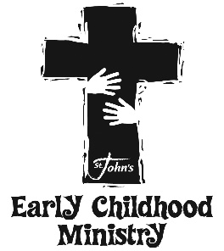

St. John’s Early Childhood Ministries Registration

PLEASE PRINT CLEARLY AND FILL IN ALL BOXES COMPLETELY.
CHILD’S FIRST NAME | MIDDLE |  |  |  | LAST |  |  | SEX
 |  |  |  |  |  |  |  | M F
ADDRESS |  |  | CITY, STATE |  |  |  | ZIP
HOME PHONE |  | DATE OF BIRTH |  | BAPTIZED? |  | IF YES, WHEN?
( ) |  | / / |  | YES NO |  | / /
ALLERGIES/MEDICAL CONDITIONS

Other children in your household
CHILD’S NAME | DATE OF BIRTH | BAPTIZED? | ALLERGIES
CHILD’S NAME | DATE OF BIRTH | BAPTIZED? | ALLERGIES
Parents/Guardians
MOTHER/GUARDIAN NAME | CELL PHONE | MARITAL STATUS  SINGLE  MARRIED  DIVORCED  SEPARATED  WIDOWED
EMAIL ADDRESS
FATHER/GUARDIAN NAME | CELL PHONE
EMAIL ADDRESS
Emergency Contact (other than parents)
NAME | RELATION TO CHILD | PHONE
Please list any other adults who are authorized to pick your up child. ID may be required at time of pick up.
Children will NOT be released to minors.
NAME | RELATION TO CHILD
NAME | RELATION TO CHILD  OFFICE USE ONLY  Mom’sLife:________  1st Time visitor: ______  Special: _______

Completed Family Participation form, All forms may be found @ http://www.stjohnsorange.org/ministries/children/

Please list any additional information you may want to communicate with St. John’s Staff:
_____________________________________________________________________________________________________________________________________________________________________________________________________________________________________________________________________________________________________________________________________

Signed Date

For more information please contact Irma Bates at (714) 288-4490 or ibates@stjohnsorange.org
Revised Jul-19

St. John’s Lutheran Church 154 South Shaffer Street, Orange, CA 92866 (714) 288-4400

